/* Samuel Greenlee */

/* SQL Server */

/* Use Statement for SamsCarsSGG Database */

Use SamsCarsSGG;

/* AND Query */

/* What are the cars who were added on 2021-03-26, and were Fords? */

Select Make, Date_Added

From Car

Where Make = 'Ford' AND Date_Added = '2021-03-26';

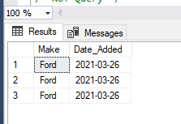

/* OR Query */

/* What are the listings of cars that either contain Front-Wheel-Drive drive trains, or All-Wheel-Drive drive train? */

Select *

From Car

Where Drive_Train = 'Front-Wheel-Drive' OR Drive_Train = 'All-Wheel-Drive'

Order by Drive_Train Desc;

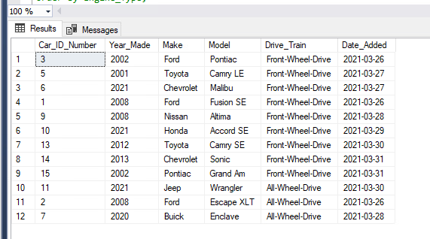

/* NOT Query */

/* What are the listings of engines that are not of the engine type V6? */

Select *

From Engine

Where Not Engine_Type = 'V6'

Order by Engine_Type;

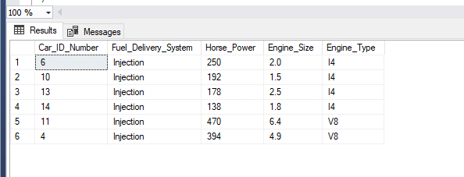

/* BETWEEN, AND Query */

/* What are the listings of engines that are between 3.0 and 4.0 in engine size? */

Select *

From Engine

Where Engine_Size Between 3.0 And 4.0;

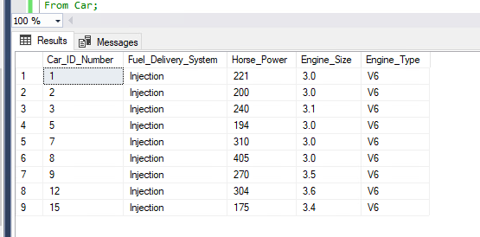

/* Calculated Field Query*/

/* How long has past since the addition of each car? */

Select Date_Added, DATEDIFF(Day, Date_Added, GetDate()) As 'Days_Past_Since_Added'

From Car;

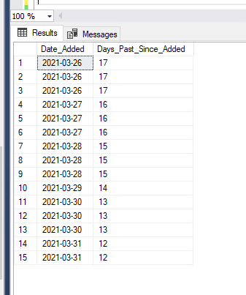

/* Aggregate Function, Group By Query */

/* What would my forward gear count be if I want to add three more to each transmission? */

Select Car_ID_Number, SUM(Forward_Gear_Count + 3) as 'New_Forward_Gear_Count', Shift_Ability

From Transmission

Group By Car_ID_Number, Shift_Ability;

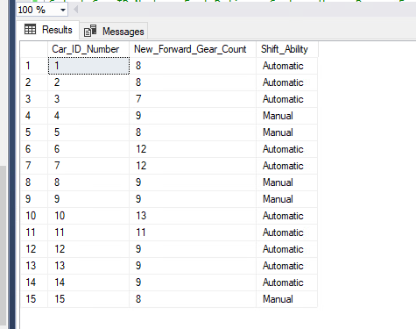

/* Aggregate Function, Group By and Having Query*/

/* How much bigger would each engine listing be if it was under the engine size of 6.0?*/

Select Car_ID_Number, Fuel_Delivery_System, Horse_Power, Engine_Size, Engine_Type, SUM(6.0 - Engine_Size) as 'Size_Difference'

From Engine

Group By Car_ID_Number, Fuel_Delivery_System, Horse_Power, Engine_Size, Engine_Type

Having Engine_Size < 6.0;

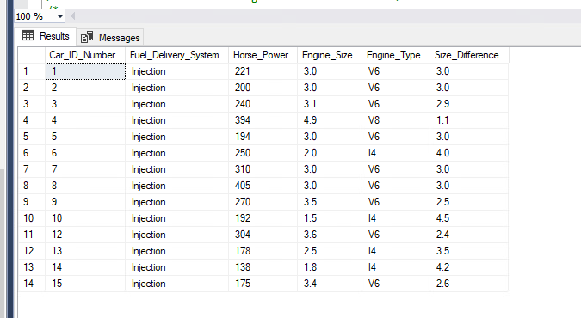

/* Top Values Query */

/* What are the first three listings of the tires table? */

Select Top 3 *

From Tires;

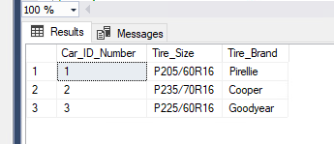

/* Inner Join Query */

/* What car goes with what engine type?*/

Select c.Car_ID_Number, Year_Made, Make, Model, Drive_Train, Date_Added, Engine_Type

From Car as c

Inner Join Engine as e

On c.Car_ID_Number = e.Car_ID_Number;

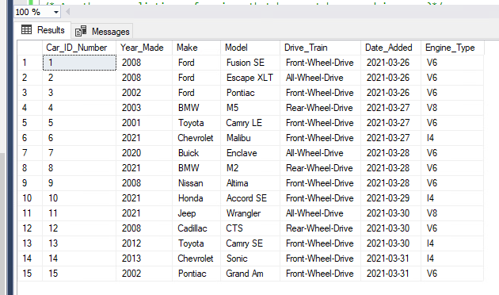

/* Outer Join, AND, WHERE Query */

/* Are there any listings of engines that have not been used in a car?*/

Select e.Car_ID_Number, Fuel_Delivery_System, Horse_Power, Engine_Size, Engine_Type, Year_Made, Make, Model

From Engine as e

Left Outer Join Car as c

On e.Car_ID_Number = c.Car_ID_Number

Where Year_Made = Null AND Make = Null AND Model = Null;

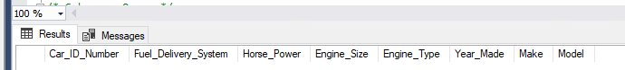

/* Subquery Query */

/* What are the car listings for cars who have the fuel tank capacity of 17.5 gallons? */

Select *

From Car

Where Car_ID_Number IN (

Select Car_ID_Number

From Fuel

Where Fuel_Tank_Capacity = '17.5 gallons'

);

